**EMPLOYMENT AND UNEMPLOYMENT**

The**employment rate**isthe percent of the total number of people in the labour force who have a job.The **unemployment rate**isthe percent of the total number of people in the labour force who are unemployed. The U.S. Census Bureau considers the unemployed those who are *“jobless, looking for jobs, and available for work”*. Being unemployed does not mean not participating in the labour market, since unemployed actually participate by looking for a job. Retired people do not count because they are not looking for jobs; an individual is considered unemployed if he or she does not currently have a job and has been actively seeking a job during the past four weeks.

**Labour force** comprehendsthe total number of workers (16 years old and over), employed or unemployed. **Labour force participation rate**isthe percentage of adults (people 16 and over) in the labour force (working or actively looking for a job). It is given by the ratio of labour force and adult population multiplied by 100.

$$Labour force participation rate=\frac{employed+unemployed}{adult population}×100$$

$$Labour force participation rate=\frac{labour force}{adult population}×100$$

The labour force participation rate must not be confused with the employment and unemployment rate. The latter is the ratio between the number of unemployed individuals and labour force multiplied by 100.

$$Unemployment rate=\frac{unemployed}{labour force}×100$$

The unemployment rate is usually considered a good indicator of how difficult it is to find a job and whether a country is in recession or growth. However, it could either overstate (even if the labour market is healthy, it takes time to find the right job; meanwhile, you are “unemployed”) or understate (you are not “unemployed” if you have given up looking for a job because there are no jobs available) the real level of unemployment. There are some problems with formal unemployment statistics because there are three particular categories of workers:

* **Discouraged workers:** nonworking people who have given up looking for work for the time being. They are not considered unemployed. The deeper the recession, the more discouraged workers there are.
* **Marginally attached workers:** thosewho were available and actively looked for work recently but are not currently looking (in the past 12 months but *not* in the past 4 weeks)
* **Underemployed workers:** people who work part time because they cannot find full-time jobs. They participate in the labour market but not as much as their potential would allow them to do. In this case, the unemployment rate is underestimated.

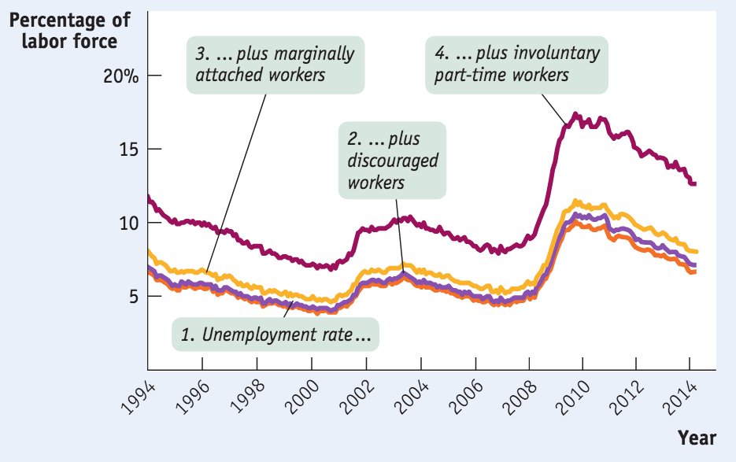

The unemployment is a proxy of the wealth of the labour market system, yet it does not measure the categories mentioned before and the quality of jobs or how well people are matched to their jobs.

Economists also look at other indicators for measuring the quality of labour market:

* **Labour force participation rate:** it is important because it provides information also about female participation and about education.
* **Number of full-time jobs**
* **Average wages**

The unemployment rate is an average measure, yet in reality unemployment rates differ a lot if we consider different groups of population and therefore it is a very heterogeneous measure.

There are three types of unemployment:

* **Frictional:** unemployment due to the time workers spend in job search. Scarcity of information creates frictional unemployment. Matching people to jobs takes time.
* **Structural:** more people are seeking jobs in a particular labor market than there are jobs available at the current wage rate, even when the economy is at the peak of the business cycle. Some causes are minimum wages, efficiency wages (wages that employers set above the equilibrium rate as an incentive for better employee performance), side effects of government policies and mismatches between employees and employers.
* **Cyclical:** unemployment correlated with the business cycle—the deviation from the natural rate. Lower growth is usually correlated with higher unemployment for two reasons: when GDP falls, firms lay off workers. Idle labor and capital → economic growth not being maximized → ↓ ability of the economy to create more jobs.

**Frictional** and **structural** unemployment are always present; they are “**natural**.”

Natural unemployment = frictional unemployment + structural unemployment.

**Actual** unemployment = **natural** unemployment + **cyclical** unemployment

In a healthy year many workers move into and out of both employment and unemployment each month.

We need estimates of the natural rate of unemployment both to make forecasts and to conduct policy analyses. What causes it to change?

* Changes in characteristics of the labor force
* Changing demographics
* Changes in labor market institutions
* Unions, temp agencies, and new technology
* Changes in government policies
* Job training programs